**Waterfall Model Documents**

**Document 1- Business case document template**

**➢ Why is this project initiated?**

* The initiation of this project arises from the imperative need to modernize and optimize the operations of the retail shop's buying and selling processes.
* Manual recording of transactions is not only time-consuming but also prone to errors, hindering efficiency and accuracy. By implementing a Point of Sale (POS) terminal management system, the retail shop aims to address these challenges comprehensively.
* The system's automation capabilities will streamline transaction recording, calculate totals accurately, and provide real-time updates to inventory levels. This will not only improve operational efficiency but also enhance the overall customer experience.
* Customers will benefit from a smoother checkout process, where they can easily view item prices, select their preferred payment method, and promptly receive detailed receipts.
* The POS system will enable the retail shop to gain valuable insights into sales performance, inventory management, and financial analytics through comprehensive reporting features.

**➢ What are the current problems?**

* The current operations in the retail shop are plagued by inefficiencies and inaccuracies stemming from manual transaction recording and inventory management processes.
* These manual methods not only consume valuable time and resources but also introduce a significant risk of errors.
* Cashiers must carefully input each item and its price, leading to delays at the checkout counter, particularly during busy periods.
* Moreover, human errors in recording prices or calculating totals can result in inconsistency in sales records and inventory levels, undermining the accuracy of financial reporting and potentially leading to financial losses.
* The lack of real-time updates to inventory levels further compounds the issue, making it difficult for the retail shop to maintain optimal stock levels and meet customer demand.
* Consequently, customers may experience dissatisfaction due to prolonged checkout processes and errors in their receipts, adversely affecting the shop's reputation and bottom line.
* Additionally, the reliance on manual processes hampers the retail shop's ability to gather comprehensive data on sales performance, inventory turnover, and customer preferences, hindering its capacity to make informed business decisions and drive growth.
* Overall, the current problems underscore the urgent need for a more streamlined and automated Point of Sale (POS) terminal management system to address these challenges effectively.

**➢ With this project how many problems could be solved?**

The implementation of the Point of Sale (POS) terminal management system project has the potential to address several problems encountered in the retail shop's operations. Here's a summary of the issues that could be solved:

**🡪Inefficiency at Checkout:** The manual recording of transactions can be replaced with automated processes, reducing checkout times and improving overall efficiency at the point of sale.

**🡪Errors in Transaction Recording:** Automation decreases the likelihood of human errors in recording prices or calculating totals, leading to more accurate sales records and financial reporting.

**🡪Inventory Management Challenges:** Real-time updates to inventory levels provided by the POS system enable better management of stock levels, reducing instances of overstocking or stockouts.

**🡪Customer Dissatisfaction:** A smoother checkout process and accurate receipts enhance the customer experience, leading to increased satisfaction and loyalty.

**🡪Limited Insights:** The POS system generates comprehensive reports on sales performance, inventory turnover, and customer preferences, providing valuable insights for decision-making and business optimization.

**➢ What are the resources required?**

**Hardware:** POS terminals/devices, Networking equipment.

**Software:** POS software, Operating system, Database management system.

**Infrastructure:** Central server, Backup systems.

**Human Resources:** IT staff, Training staff

**Financial Resources:** Budget for hardware and software procurement, Implementation costs, Ongoing maintenance and support

**Data:** Product information, Sales data, Inventory data

**Security Measures:** Security software, Compliance measures

**➢ How much organizational change is required to adopt this technology?**

The adoption of a Point of Sale (POS) terminal management system typically involves a significant degree of organizational change, as it affects various aspects of the retail shop's operations, processes, and workforce. Here's an overview of the organizational changes required:

**Cultural Shift:** Employees may need to embrace a mindset of innovation, adaptability, and continuous learning to effectively utilize the POS system and maximize its benefits.

**Process Redesign:** The introduction of a POS system may require the redesign of existing processes and workflows to align with the capabilities and functionalities of the technology. This could involve redefining how sales transactions are recorded, inventory is managed, and customer interactions are conducted.

**Training and Education:** Comprehensive training programs will be necessary to educate employees on how to use the POS system efficiently and effectively. Training should cover various aspects, including system navigation, transaction processing, inventory management, and troubleshooting.

**Role Redefinition:** With the automation provided by the POS system, the roles and responsibilities of employees may evolve. For example, cashiers may transition from primarily manual transaction processing to more customer-focused roles, such as providing personalized assistance and upselling/cross-selling products.

**Communication and Collaboration:** Effective communication and collaboration among different departments and teams are crucial during the implementation of a POS system. Clear communication channels should be established to ensure that all stakeholders are informed about the changes, their roles, and expectations.

**Performance Metrics and Evaluation:** The organization may need to redefine performance metrics and evaluation criteria to align with the objectives of the POS system implementation. Key performance indicators (KPIs) related to sales efficiency, inventory turnover, customer satisfaction, and revenue growth may need to be established or adjusted.

**Change Management:** Implementing a POS system involves managing change effectively to minimize resistance and maximize acceptance among employees. Change management strategies, such as stakeholder engagement, communication plans, and addressing concerns and feedback, are essential to facilitate a smooth transition.

**Integration with Existing Systems:** Depending on the retail shop's existing infrastructure, integrating the POS system with other systems (e.g., accounting software, CRM systems, e-commerce platforms) may be necessary. This requires coordination and collaboration between IT teams and vendors.

**➢ Time frame to recover ROI?**

The time frame of the project is 18 months so the recover of ROI could be probably after 1 year.

**➢ How to identify Stakeholders?**

Identifying stakeholders for a Point of Sale (POS) terminal management system project involves identifying individuals, groups, or organizations that have an interest or will be affected by the implementation of the system.

* Identify Project Team Members
* Determine Affected Departments
* Engage End Users
* Consider External Stakeholders (customers, suppliers, vendors, partners, regulatory bodies, and industry associations.)
* Review Organizational Structure
* Assess Influence and Interest

**Document 2: BA Strategy**

**Write BA Approach strategy**

**🡪 What Elicitation Techniques to apply**

**Interviews:** Conduct one-on-one or group interviews with stakeholders to gather detailed information about their needs, expectations, and concerns regarding the POS system.

**Surveys/Questionnaires:** Distribute surveys or questionnaires to a wider range of stakeholders to gather input on their preferences, requirements, and priorities for the POS system.

**Workshops/Focus Groups:** Organize workshops or focus groups with cross-functional teams or departments to facilitate discussions and brainstorming sessions about the POS system.

**Observation:** Observe stakeholders in their natural work environment to gain firsthand insights into their current processes, workflows, and pain points related to the existing POS system or manual operations.

**Document Analysis:** Review existing documentation, such as sales reports, inventory records, customer feedback, and system requirements documents, to identify relevant information and requirements for the POS system.

**Joint Application Design (JAD):** Facilitate JAD sessions with stakeholders to collaboratively define system requirements, design workflows, and prioritize features for the POS system.

**Expert Interviews:** Consult with subject matter experts (SMEs) or industry professionals who have experience with POS systems or retail operations to gather expert opinions, best practices, and recommendations for system design and implementation.

* **How to do Stakeholder Analysis RACI/ILS**
* Identifying all stakeholders involved in the project. This includes internal stakeholders such as project team members, executives, and department heads, as well as external stakeholders like customers, suppliers, and regulatory agencies.
* Develop a RACI/ILS matrix that maps out the stakeholders' roles and responsibilities for each project activity. This matrix provides a clear visual representation of who is responsible, accountable, consulted, and informed for each task.
* Stakeholder analysis using RACI/ILS involves identifying stakeholders' roles and responsibilities in relation to specific project activities. RACI stands for Responsible, Accountable, Consulted, and Informed, while ILS stands for Involvement, Leadership, and Support.
* Once the RACI/ILS matrix is established, communicate the roles and expectations to all stakeholders involved in the project. Ensure that everyone understands their responsibilities and knows who to consult or inform for each activity.
* Periodically review and update the RACI/ILS matrix as the project progresses, new stakeholders are identified, or roles and responsibilities change.
* **What Documents to Write**
* **Project Charter:** This document outlines the project's purpose, objectives, scope, stakeholders, and high-level approach. It provides formal authorization for the project and serves as a reference for key project information.
* **Project Plan:** The project plan details the project's scope, timeline, milestones, deliverables, resource allocation, and budget. It provides a roadmap for project execution and serves as a guide for project management.
* **Requirements Document:** This document specifies the functional and non-functional requirements of the POS terminal management system, including features, functionalities, performance criteria, and constraints. It serves as a basis for system design and development.
* **System Design Document:** The system design document outlines the architecture, components, interfaces, and data flow of the POS terminal management system. It provides a blueprint for system development and integration.
* **Implementation Plan:** This document outlines the approach, activities, resources, and timeline for implementing the POS terminal management system. It includes deployment strategies, testing procedures, training plans, and transition plans.
* **Test Plan:** The test plan defines the testing strategy, objectives, scope, approach, resources, and schedule for testing the POS terminal management system. It includes test cases, scenarios, and acceptance criteria for validating system functionality and performance.
* **Risk Management Plan:** This document identifies potential risks and uncertainties associated with the POS terminal management system project and outlines strategies for risk mitigation, monitoring, and response.
* **Change Management Plan:** The change management plan outlines how changes to the project scope, requirements, or deliverables will be managed, communicated, and implemented throughout the project lifecycle.
* **Documentation Standards and Guidelines:** Standardized templates, formats, and guidelines for documenting project-related information ensure consistency, clarity, and completeness across all project documents.
* **Project Closure Report:** The project closure report summarizes the project's outcomes, lessons learned, achievements, challenges, and recommendations for future projects. It provides closure to the project and facilitates knowledge transfer and continuous improvement.
* **What process to follow to Sign off on the Documents**

Signing off on project documents is an essential step to ensure that stakeholders formally acknowledge and approve the content and decisions outlined in the documents. Here's a suggested process to follow for signing off on project documents:

* Review and Finalize Documents
* Distribute Documents for Review
* Address Feedback and Revisions
* Obtain Approval
* Document Sign-off
* Document Retention
* Communication of Approval
* Implementation and Execution
* **How to take Approvals from the Client**

Taking approvals from the client is a crucial step in ensuring that project deliverables meet their expectations and requirements. Here's a recommended process for obtaining approvals from the client:

* Schedule Review Meetings
* Prepare Documentation
* Provide Context and Explanation
* Review Session
* Address Feedback and Revisions
* Document Changes
* Seek Formal Approval
* Obtain Sign-off
* Document Approval
* Proceed with Implementation
* **What Communication Channels to establish and implement**

Establishing effective communication channels is crucial for ensuring seamless communication among project stakeholders, including clients, team members, and other relevant parties. Here are some communication channels to consider implementing for a Point of Sale (POS) terminal management system project:

* Email
* Project Management Software
* Instant Messaging (Microsoft Teams, skype)
* Video Conferencing
* Regular Status Meetings
* Stakeholder Reports
* Social Media Channels
* **How to Handle Change Requests**

Handling change requests effectively is essential for managing scope, schedule, and budget in a Point of Sale (POS) terminal management system project. Here's a recommended process for handling change requests:

* Submission of Change Requests: (scope, schedule, budget).
* Change Request Review
* Assessment of Impact
* Documentation and Analysis
* Decision Making
* Communication
* Implementation of Approved Changes
* Monitoring and Control
* Documentation
* **How to update the progress of the project to the Stakeholders**

Updating stakeholders on the progress of the project is essential for maintaining transparency, managing expectations, and fostering stakeholder engagement. Here's a recommended process for updating stakeholders on the progress of a Point of Sale (POS) terminal management system project:

* Establish Communication Plan
* Identify Key Stakeholders
* Define Reporting Metrics
* Regular Progress Updates
* Prepare Status Reports
* Use Visual Aids
* Highlight Achievements
* Address Challenges and Risks
* Seek Feedback and Input
* Document Communication
* Adapt and Adjust
* **How to take signoff on the UAT- Client Project Acceptance Form**

Taking signoff on the User Acceptance Testing (UAT) - Client Project Acceptance Form is a critical step in the project closure process, indicating that the client has reviewed the system, performed testing, and accepts it as meeting their requirements. Here's a step-by-step guide on how to take signoff on the UAT - Client Project Acceptance Form:

* Schedule UAT Review Meeting: Ensure that all relevant stakeholders, including representatives from the client's team and project team members, are present for the meeting.
* Prepare UAT - Client Project Acceptance Form: Create a formal document that outlines the acceptance criteria, including functional and non-functional requirements, that the system must meet for the client to accept it.
* Conduct UAT Review: During the UAT review meeting, present the system to the client and walk them through the functionalities and features. Provide instructions on how to perform testing and encourage the client to thoroughly test the system against the acceptance criteria outlined in the UAT - Client Project Acceptance Form.
* Address Feedback and Issues: As the client performs testing, address any issues, defects, or concerns that arise promptly. Work collaboratively with the client to resolve issues and ensure that the system meets their expectations.
* Document Test Results: Document the results of the UAT, including any defects identified, actions taken to address them, and the overall outcome of the testing process. Keep detailed records to provide evidence of the system's performance during UAT.
* Review Acceptance Criteria: Review the acceptance criteria outlined in the UAT - Client Project Acceptance Form to ensure that all requirements have been met satisfactorily. Verify that the system meets the client's expectations and aligns with the agreed-upon scope and specifications.
* Seek Client Signoff: Once the client has completed testing and is satisfied with the system's performance, present the UAT - Client Project Acceptance Form for signoff. Clearly explain the implications of signing the form and ensure that the client understands the significance of accepting the system.
* Obtain Signatures: Request the client to sign the UAT - Client Project Acceptance Form to indicate their formal acceptance of the system. Ensure that all necessary stakeholders, including representatives from both the client and project teams, sign the form.
* Archive Documentation: After obtaining signoff, archive the UAT - Client Project Acceptance Form, along with any supporting documentation, in a secure location for future reference and audit purposes. This documentation serves as evidence of the client's acceptance of the system.
* Communicate Acceptance: Communicate the client's acceptance of the system to all relevant stakeholders, including project team members, management, and other stakeholders involved in the project. Ensure that everyone is aware of the project's successful completion and acceptance by the client.

**Document 3- Functional Specifications**

|  |  |
| --- | --- |
| Project Name | Point of sales terminal management system |
| Customer Name | Mr. David |
| Project Version | 001 |
| Project Sponsor | Mr. Davin |
| Project Manager | Mr. Mike |
| Project Initiated Date | 24/03/2024 |

**Functional Requirement specifications:**

|  |  |  |  |
| --- | --- | --- | --- |
| Req ID | Req Name | Req Description | Priority |
| FR0001 | User Authentication | The system must authenticate users before granting access. This includes username/password authentication and may include additional authentication methods such as biometrics. | High |
| FR0002 | Item Scanning | The system must allow cashiers to scan items for purchase using barcode scanners or manual entry. | High |
| FR0003 | Sales Transaction | The system must process sales transactions, calculating the total cost of items including taxes and discounts, and generating receipts for customers. | High |
| FR0004 | Payment Processing | The system must support various payment methods including cash, credit/debit cards, and electronic payments. It should integrate with payment gateways to process payments securely. | High |
| FR0005 | Inventory Management | The system must update inventory levels in real-time as items are sold, ensuring accurate stock levels and triggering alerts for low stock items. | High |
| FR0006 | Reporting | The system must provide reporting capabilities, allowing users to generate sales reports, inventory reports, and financial reports. Reports should be customizable and exportable. | Medium |
| FR0007 | Loyalty Program | The system must support loyalty programs, allowing customers to earn and redeem points or rewards for purchases. | Medium |
| FR0008 | Offline Mode | The system must have an offline mode that allows it to continue processing sales transactions even when internet connectivity is unavailable. | Low |
| FR0009 | User Roles and Permissions | The system must support different user roles (e.g., cashier, manager) with varying levels of permissions to access system functionalities. | Medium |

**Document 4- Requirement Traceability Matrix**



**Document 5- BRD Template**

**1.Document Versions**

|  |  |  |
| --- | --- | --- |
| Date | Version Number | Document Changes |
| 20/05/2024 | 0.1 | Initial Draft |
|  |  |  |
|  |  |  |
|  |  |  |
|  |  |  |
|  |  |  |

**2. Approvals**

|  |  |  |  |  |
| --- | --- | --- | --- | --- |
| **Role** | **Name** | **Title** | **Signature** | **Date** |
| Project Sponser | Mr. Davin |  |  | 5/10/2024 |
| Business Owner | Mr. Jack |  |  | 5/10/2024 |
| Project Manager | Mr. Mike |  |  | 5/10/2024 |
| System Architect | Mr. Karthik |  |  | 5/10/2024 |
| Development Lead | Ms. Juhi |  |  | 5/10/2024 |
| User Experience Lead | Mr. Vandanam |  |  | 5/10/2024 |
| Quality Lead | Mr. Ben |  |  | 5/10/2024 |
| Content Lead | Mr. Charle |  |  | 5/10/2024 |

**3. RACI Chart**

In the RASCI model:

**R stands for Responsible:** These are the individuals or roles responsible for completing the task or making the decision.

**A stands for Accountable:** This is the person who is ultimately answerable for the completion of the task or the decision-making process. There should be only one person accountable for each task or decision.

**S stands for Support:** These are the individuals or roles that provide assistance or support to those responsible for completing the task.

**C stands for Consulted:** These are the individuals or roles that need to be consulted before a decision is made or action is taken. Their input is valuable for the completion of the task.

**I stands for Informed:** These are the individuals or roles that need to be kept informed about the progress or outcome of the task or decision-making process. They are not directly involved but need to be aware of what's happening.



**4. Introduction**

* 1. **Business Goals**
* The business goal of the Point of Sale (POS) Terminal Management System is to streamline the buying and selling process in a retail shop, ensuring accuracy, efficiency, and customer satisfaction.
* The design element for the POS system involves a user-friendly interface that facilitates seamless transactions. When a customer arrives at the checkout, the cashier utilizes the system to record each item's details, including description and price. As each item is scanned or manually entered, the system updates the running sales transaction, displaying the item information for verification.

**4.2 Business Objectives**

* The primary business objective of implementing the Point of Sale (POS) Terminal Management System in the retail shop is to enhance operational efficiency and customer satisfaction. By streamlining the checkout process, the system aims to minimize wait times for customers while ensuring accurate recording of sales transactions. This includes automating inventory management, sales tracking, and payment processing to reduce errors and discrepancies.
* Additionally, the system facilitates compliance with tax regulations by accurately calculating and applying taxes to each transaction. Ultimately, these improvements contribute to a smoother, more efficient shopping experience for customers and enable the retail shop to operate more effectively, leading to increased customer loyalty and profitability.

**4.3 Business Rules**

* Firstly, pricing policies dictate that each item in our inventory must have a predefined price, maintaining consistency and transparency in transactions.
* Secondly, tax calculations adhere strictly to local regulations, with the system accurately applying taxes to applicable items based on current tax rates.
* Additionally, inventory management procedures are in place to track stock levels in real-time, updating quantities with each sale and issuing alerts for low inventory thresholds to prevent stockouts.
* Payment processing protocols outline acceptable payment methods, including cash, credit/debit cards, checks, or digital payments, ensuring convenience for customers.
* Employee authentication procedures require cashiers and staff members to log in with unique credentials, fostering accountability and security in transactions.
* Discounts and promotions are applied according to predefined rules, such as percentage discounts or loyalty program rewards, enhancing customer engagement and retention.
* Receipt generation policies ensure that detailed receipts are issued for each transaction, providing customers with comprehensive documentation of their purchases.
* These organization policies, procedures, and regulatory guidelines collectively ensure the reliability, accuracy, compliance, and customer satisfaction of our POS system within the retail shop environment.

**4.4 Background**

The Point of Sale (POS) Terminal Management System project stemmed from a thorough evaluation of the retail shop's operational inefficiencies and challenges. Historically, the shop relied on manual processes, including cash registers and paper-based inventory tracking, which led to numerous business issues. These issues encompassed inaccuracies in transaction recording, difficulty in managing inventory levels effectively, prolonged checkout times due to manual processes, and limited payment options for customers.

Recognizing the need for modernization and improved efficiency, stakeholders initiated discussions to explore solutions. The proposal for implementing a POS Terminal Management System emerged as a strategic response to these challenges. The anticipated benefits of the project include enhanced accuracy in transaction recording and inventory management, increased operational efficiency through streamlined checkout processes, expanded payment options for customers, and improved inventory management capabilities.

Overall, the project aims to address existing business issues, optimize operations, and elevate the customer experience within the retail shop.

**4.5 Project Objective**

* The project objectives outline the overarching goals of developing the Point of Sale (POS) Terminal Management System, including its functionalities, alignment with business objectives, and requirements for interaction with other systems.
* The primary objective of the project is to implement a modern POS Terminal Management System that enhances operational efficiency, accuracy, and customer satisfaction within the retail shop environment.
* The system will accurately record sales transactions, including item details, prices, quantities, and discounts.
* It will maintain real-time inventory tracking, updating stock levels with each sale to prevent stockouts or overstocking.
* The system will facilitate a streamlined checkout process, minimizing wait times for customers and improving overall efficiency.
* It will support various payment methods, including cash, credit/debit cards, checks, and digital payments, offering flexibility for customers.
* The system will generate detailed receipts for each transaction, providing customers with itemized purchase information.
* By streamlining the checkout process and offering multiple payment options, the system aligns with the business objective of enhancing customer satisfaction.
* By achieving these project objectives, the POS Terminal Management System will contribute to the overall success and growth of the retail shop, enhancing operational efficiency, accuracy, and customer satisfaction.

**4.6 Project Scope**

**4.6.1 In Scope Functionality**

In-scope functionality refers to the features and capabilities that will be developed and included within the Point of Sale (POS) Terminal Management System project. Here's a list of functionalities planned for inclusion:

* + Record sales transactions accurately, including item details, prices, quantities, and discounts.
  + Maintain real-time inventory tracking, updating stock levels with each sale to prevent stockouts or overstocking.
  + Provide a user-friendly interface for cashiers to input and manage sales transactions efficiently.
  + Calculate taxes and apply them to applicable items based on predefined tax rates.
  + Generate detailed receipts for each transaction, itemizing purchased items, total amounts paid, taxes, and payment methods.
  + Support various payment methods, including cash, credit/debit cards, checks, and digital payments, offering flexibility for customers.
  + Implement security measures to protect customer payment information and ensure compliance with data protection regulations.
  + Enable user authentication for cashiers or staff members, ensuring accountability and security in transactions.
  + Allow for returns and refunds according to the shop's policies, with appropriate adjustments to inventory and sales records.
  + Integrate with the inventory management system to update stock levels in real-time and maintain accurate inventory records.
  + Provide reporting and analytics capabilities to track sales performance, inventory turnover, and customer preferences.
  + Offer administrative features for system configuration, such as setting up new products, managing user permissions, and configuring tax rates.
  + Ensure compatibility with existing hardware infrastructure, including POS terminals, barcode scanners, and receipt printers.

**4.6.2 Out Scope Functionality**

* Integration with CRM systems for managing customer interactions, preferences, and profiles.
* Integration with e-commerce platforms for online sales and inventory management.
* Support for managing multiple retail locations or franchises from a centralized system.

**5. Assumptions**

* The POS system assumes compatibility with existing hardware infrastructure, including POS terminals, barcode scanners, receipt printers, and cash drawers.
* It is assumed that the system will have access to reliable internet connectivity for real-time communication with external services, such as payment gateways and inventory management systems.
* It is assumed that the POS system will be reliable and available during business hours, with minimal downtime or system failures that could disrupt operations.
* The system assumes scalability to accommodate future growth and expansion of the retail shop, including support for additional products, stores, and transaction volumes.
* Assumption is made regarding the design of an intuitive and user-friendly interface for cashiers to facilitate efficient transaction processing and minimize training requirements.
* It is assumed that backup and recovery procedures will be in place to protect against data loss and ensure business continuity in the event of system failures or disasters.

**6. Constraints**

* The project may be constrained by budget limitations, requiring cost-effective solutions and careful allocation of resources to stay within budget constraints.
* There may be time constraints for project completion, such as deadlines for system implementation before peak shopping seasons or regulatory compliance deadlines.
* Limited availability of skilled personnel, hardware components, or software licenses may constrain the project's progress and require careful resource management.
* Constraints related to system scalability may arise, requiring careful consideration of future growth and expansion to accommodate increasing transaction volumes and additional features.
* Integration with existing systems, such as inventory management, accounting, and payment processing systems, may present challenges and constraints related to data exchange, compatibility, and performance.
* Constraints related to user acceptance and adoption of the new POS system may require thorough user training, effective communication, and stakeholder engagement strategies.

**7. Risks**

**Technological Risks:**

* Risk of hardware components, such as POS terminals or barcode scanners, malfunctioning or failing, leading to system downtime.
* Risk of compatibility issues with existing software systems, requiring extensive troubleshooting and potential delays in implementation.
* Risk of unreliable internet connectivity affecting real-time communication with external services, such as payment gateways or inventory management systems.

**Skills Risks:**

* Risk of insufficient expertise or experience among project team members in developing and implementing POS systems, requiring additional training or external assistance.
* Risk of key team members leaving the project or organization, resulting in knowledge loss and potential delays in project delivery.

**Political Risks:**

* Risk of resistance or pushback from internal stakeholders, such as employees or management, due to concerns about change management or perceived impacts on existing processes.
* Risk of conflicting priorities or agendas among project stakeholders, leading to delays or changes in project scope.

**Business Risks:**

* Risk of competitors introducing similar POS solutions or innovative technologies, affecting the market positioning and adoption of the project's solution.
* Risk of economic downturns or market fluctuations impacting consumer spending habits and overall business performance, affecting the ROI of the project.

**Requirements Risks:**

* Risk of expanding project scope beyond the initial requirements, leading to budget overruns, timeline delays, and potential dissatisfaction with the final product.
* Risk of misunderstanding or misinterpretation of user requirements, resulting in the delivery of a solution that does not meet stakeholder expectations.

**8. Business Process Overview**

The business process overview for the Point of Sale (POS) Terminal Management System involves a series of interconnected activities aimed at facilitating efficient sales transactions and inventory management within the retail shop environment. At its core, the process begins when a customer arrives at the checkout counter with items to purchase. The cashier utilizes the POS system to scan or manually enter each item, recording details such as description, price, and quantity. As each item is added to the transaction, the system updates the running sales total and adjusts inventory levels in real-time.

Once all items have been processed, the system calculates the total amount due, including applicable taxes, and presents this information to the customer. The customer selects their preferred payment method, and the cashier completes the transaction, generating a detailed receipt for the customer. Simultaneously, the POS system automatically updates inventory records to reflect the items sold. This seamless process not only streamlines the checkout experience for customers but also ensures accurate recording of sales transactions and real-time inventory management, ultimately contributing to improved operational efficiency and customer satisfaction within the retail shop.

**8.1 Legacy System (AS-IS)**

In a legacy system, the process of managing point of sale (POS) transactions typically involves manual entry of sales data, limited automation, and reliance on physical records. Here's a brief explanation of the process and a drawn process flow diagram:

**Customer Purchase:** The customer brings items to the cashier for purchase.

**Manual Item Entry:** The cashier manually enters each item's description, price, and quantity into the POS system.

**Calculation of Total:** The POS system calculates the total cost of the items based on the entered prices and quantities.

**Payment Processing:** The customer selects a payment method (cash, credit/debit card, etc.) and completes the payment transaction.

**Receipt Generation:** The POS system generates a receipt detailing the purchased items, total cost, payment method, and any applicable taxes or discounts.

**Inventory Update:** After the transaction is completed, the inventory records are manually updated to reflect the items sold and current stock levels.

**End of Day Reconciliation:** At the end of the business day, the cashier reconciles the sales transactions, compares them with the physical inventory, and prepares reports for accounting purposes.

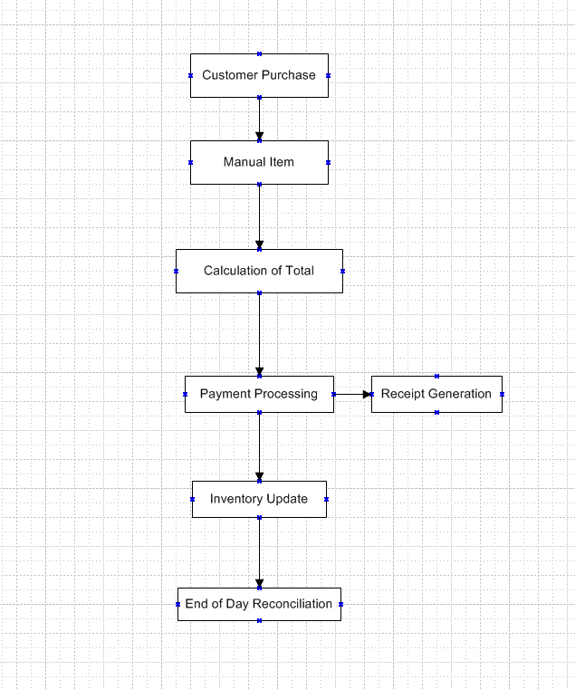

In this diagram:

Arrows indicate the flow of the process from one step to another.

Boxes represent the individual steps or tasks involved in the process.

The process starts with "Customer Purchase" and ends with "End of Day Reconciliation".

Each step is dependent on the completion of the previous step, highlighting the sequential nature of the process.

**8.2 Proposed Recommendations (TO-BE)**

The recommended process for the proposed system involves implementing a modernized Point of Sale (POS) terminal management system that leverages automation, integration, and advanced features to address the challenges encountered in legacy systems. Here's an overview of the process and how the proposed system will address these challenges:

* Customer Purchase: Customers bring items to the cashier for purchase as in the legacy system.
* Automated Item Entry: Instead of manual entry, the proposed system incorporates barcode scanning technology or RFID (Radio-Frequency Identification) to automatically capture item information, eliminating the need for manual data entry and reducing errors.
* Real-time Total Calculation: The system calculates the total cost of the items in real-time, including taxes, discounts, and promotions, providing accurate and transparent pricing information to customers.
* Diverse Payment Options: The proposed system supports a variety of payment methods, including cash, credit/debit cards, mobile payments, and contactless payments, offering customers flexibility and convenience in payment options.
* Instant Receipt Generation: Upon completing the transaction, the system generates a digital receipt that can be emailed or sent via SMS to the customer's mobile device, reducing paper waste and providing a convenient record of the transaction.
* Automated Inventory Management: The system automatically updates inventory records in real-time as items are sold, ensuring accurate stock levels and triggering alerts for low stock items. Integration with the supply chain allows for automatic replenishment of inventory when necessary.
* End-of-Day Reporting: At the end of the business day, the system generates comprehensive reports on sales transactions, inventory levels, revenue, and other key performance indicators, streamlining the reconciliation process and providing valuable insights for business decision-making.
* Enhanced Security Features: The proposed system incorporates advanced security features such as encryption, tokenization, and multi-factor authentication to safeguard sensitive customer data and prevent unauthorized access or fraudulent activities.
* Scalability and Flexibility: The system is designed to be scalable and flexible, allowing for easy integration with other business systems and third-party applications. This enables customization and expansion to meet the evolving needs of the business.
* User Training and Support: Comprehensive training and support are provided to users to ensure smooth adoption and effective utilization of the new system. User-friendly interfaces and intuitive workflows are designed to minimize the learning curve and maximize productivity.

By implementing the proposed system, organizations can overcome the limitations and inefficiencies of legacy POS systems, streamline operations, enhance customer experiences, and position themselves for future growth and success in the competitive retail landscape.

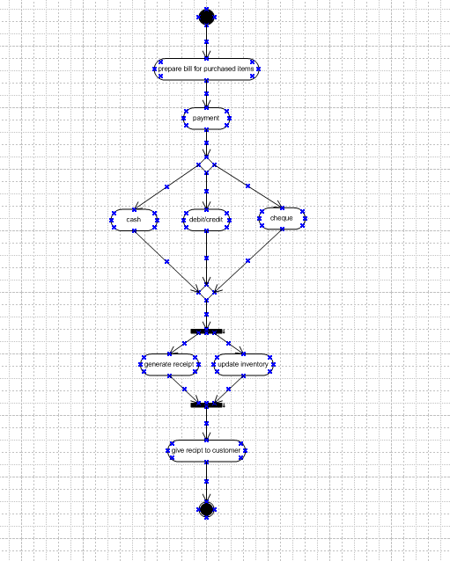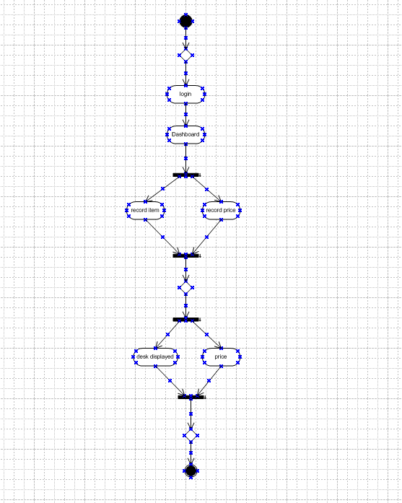

**9. Business Requirements**

|  |  |  |  |
| --- | --- | --- | --- |
| **S.No** | **Business Requirements** | **Functionality** | **Priority** |
| 1 | Secure User Authentication | User Authentication and Security | High |
| 2 | Sales Transaction Recording | Sales Management | High |
| 3 | Real Time Inventory Update | Sales Management | High |
| 4 | Multiple Payment Methods | Payment Processing | Medium |
| 5 | Sales Reporting | Reporting and Analytics | Medium |
| 6 | Performance Optimization | System Performance | Low |

**10. Appendices**

**10.1 List of Acronyms**

Here's a list of acronyms used in the context of business requirements:

* UA - User Authentication
* IS - Item Scanning
* ST - Sales Transaction
* PP - Payment Processing
* IM - Inventory Management
* RP - Reporting
* LP - Loyalty Program
* OM - Offline Mode

**10.2 Glossary of Terms**

* User Authentication: The process of verifying the identity of a user trying to access a system.
* Item Scanning: The process of using barcode or other scanning technology to identify and record items.
* Sales Transaction: The process of recording and processing the sale of goods or services.
* Payment Processing: The handling of payments from customers, including authorization, capture, and settlement.
* Inventory Management: The process of overseeing and controlling the movement and storage of inventory.
* Reporting: The creation and distribution of reports containing data and insights about various aspects of the business.
* Loyalty Program: A marketing strategy designed to encourage customers to continue patronizing a business by offering incentives or rewards.
* Offline Mode: The ability of a system to continue functioning even when not connected to the internet or network.

**10.3 Related Documents**

* Use Case Documentation: Describes the interactions between users (actors) and the system to accomplish specific tasks or goals.
* Functional Requirements Document (FRD): Details the specific functions or features that the system must perform to meet the business needs.
* Non-Functional Requirements Document (NFRD): Outlines the quality attributes or constraints that the system must satisfy, such as performance, scalability, security, and usability.
* System Design Document (SDD): Provides a comprehensive overview of the system's architecture, components, and modules, including their interactions and interfaces.
* Test Plan: Outlines the approach, scope, resources, and schedule for testing the system to ensure that it meets the specified requirements.
* User Manual: Provides instructions and guidance for users on how to use the system effectively.
* Project Charter: Defines the project's objectives, scope, stakeholders, risks, assumptions, and constraints.
* Risk Management Plan: Identifies potential risks to the project's success and outlines strategies for mitigating or addressing them.
* Change Management Plan: Describes the process for managing changes to the project scope, requirements, schedule, or budget.
* Training Materials: Includes presentations, manuals, or videos to train users or stakeholders on how to use the system.

**Document 6- Please prepare a use case diagram, activity diagram and a use**

**case specification document.**

**USE CASE DIAGRAM**

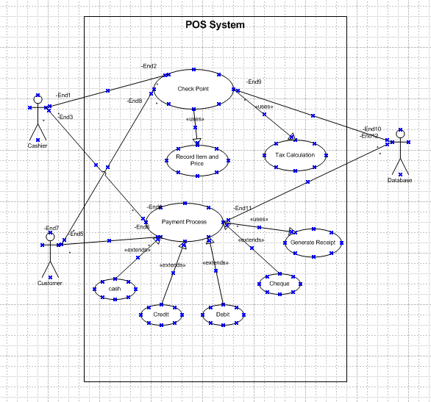

**USE CASE SPECIFICATION DOCUMENT**

|  |  |
| --- | --- |
| Use case ID | UC001 |
| Usecase Name | Scan Item |
| Actor | Cashier |
| Description | This use case involves scanning an item at the Point of Sale (POS) terminal to add it to the customer's shopping cart. |
| Pre- condition | -POS terminal is operational.  -Items are available for scanning. |
| Post- condition | Scanned items are added to the customer's shopping cart. |
| Basic flow | 🡪Cashier selects the "Scan Item" function on the POS terminal.  🡪Cashier scans the barcode or manually enters the item code using the POS scanner or keypad.  🡪System verifies the item code and retrieves the corresponding product information.  🡪System adds the item to the customer's shopping cart.  🡪Process repeats for each item to be scanned. |
| Alternative flow | If the item code cannot be scanned or entered manually, the cashier may search for the item using the POS system's search function. |
| Exceptional | If the item is not recognized or unavailable in the system, the cashier may manually enter the item details or seek assistance from a supervisor. |
| Assumptions | -Items have unique identification codes (e.g., barcodes) that can be scanned.  -POS terminal is connected to the inventory database for item verification. |
| Inputs and Output | Inputs: Item code or barcode.  Outputs: Product information (name, price, etc.) displayed on the POS screen. |

|  |  |
| --- | --- |
| Use case ID | UC002 |
| Usecase Name | Accept Payment |
| Actor | Cashier |
| Description | This use case involves accepting payment from the customer for the items purchased at the Point of Sale (POS) terminal. |
| Pre- condition | -Items are scanned and added to the customer's shopping cart.  -Total amount to be paid is calculated. |
| Post- condition | Payment is successfully processed, and the transaction is completed. |
| Basic flow | 🡪Cashier selects the "Accept Payment" function on the POS terminal.  🡪Cashier enters the total amount to be paid.  🡪Customer provides payment using the chosen method (cash, credit card, debit card, etc.).  🡪Cashier processes the payment through the POS terminal.  🡪System verifies the payment and updates the transaction status.  🡪Customer receives a payment receipt. |
| Alternative flow | If the customer's payment method fails, the cashier may request an alternative payment method. |
| Exceptional | If the POS terminal experiences technical issues, the cashier may process the payment manually or seek assistance from a supervisor. |
| Assumptions | Payment methods available are functional and supported by the POS system. |
| Inputs and Output | Inputs: Total amount to be paid, payment method.  Outputs: Payment confirmation, receipt. |
| Dependencies | Scanned items and their prices are accurate and available for payment. |

|  |  |
| --- | --- |
| Use case ID | UC003 |
| Usecase Name | Print Receipt |
| Actor | Cashier |
| Description | This use case involves printing a receipt for the customer after the payment is accepted at the Point of Sale (POS) terminal. |
| Pre- condition | -Payment is successfully accepted.  -Receipt printer is operational. |
| Post- condition | Customer receives a printed receipt. |
| Basic flow | 🡪After accepting payment, the cashier selects the "Print Receipt" function on the POS terminal.  🡪System generates a receipt containing details of the transaction, including items purchased, total amount paid, payment method, and transaction ID.  🡪System prints the receipt using the connected receipt printer.  🡪Cashier hands over the printed receipt to the customer. |
| Alternative flow | - |
| Exceptional | If the receipt printer malfunctions or runs out of paper, the cashier may handwrite a receipt or seek assistance from a supervisor. |
| Assumptions | -Receipt printer is connected and functional.  -Receipt format and content are predefined and consistent. |
| Inputs and Output | Inputs: None  Outputs: Printed receipt with transaction details. |
| Dependencies | Successful completion of the "Accept Payment" use case. |
| Business Rules | Receipt contains accurate and complete transaction information. |

|  |  |
| --- | --- |
| Use case ID | UC004 |
| Usecase Name | Print Receipt |
| Actor | Cashier |
| Description | This use case involves the printing of a receipt for a completed transaction at the checkout counter. It provides a record of the items purchased and the total amount paid by the customer. |
| Pre- condition | -The transaction has been completed successfully.  -The POS system is connected to a functional receipt printer. |
| Post- condition | -The customer receives a printed receipt for the transaction.  -A record of the transaction is stored electronically in the POS system. |
| Basic flow | 🡪After accepting payment for a transaction, the cashier selects the option to print a receipt from the POS system.  🡪 The POS system retrieves transaction details, including the list of purchased items and the total amount paid.  🡪The POS system formats the transaction details into a printable receipt format.  🡪The receipt is sent to the connected receipt printer.  🡪The receipt printer prints the receipt with transaction details.  🡪The cashier tears off the printed receipt and hands it to the customer. |
| Alternative flow | If the receipt printer is unavailable or malfunctions, the cashier may provide a handwritten receipt as an alternative. |
| Exceptional | If there are any errors or issues with printing the receipt, the cashier may need to troubleshoot the POS system or the receipt printer. |
| Assumptions | -The receipt printer is properly configured and operational.  -The POS system has access to transaction data and can generate receipts without errors. |
| Use case ID | UC005 |
| Usecase Name | Manage Inventory |
| Actor | Store Manager Inventory Clerk |
| Description | This use case involves the management of inventory within the retail store. It includes tasks such as adding new items to the inventory, updating stock levels, and removing items that are out of stock or discontinued. |
| Pre- condition | -The user has appropriate permissions to access and manage inventory.  -The inventory management system is accessible and operational. |
| Post- condition | -The inventory database is updated with the changes made by the user.  -Changes to the inventory are reflected in other systems or reports that rely on inventory data. |
| Basic flow | The user selects the option to manage inventory and chooses the desired action (e.g., add item, update stock levels, remove item).  For adding a new item:  a. The user enters details of the new item, such as name, description, category, and price.  b. The system assigns a unique identifier (e.g., SKU) to the new item.  c. The user specifies the initial stock level for the new item.  For updating stock levels:  a. The user selects an existing item from the inventory.  b. The user adjusts the stock level based on received shipments, sales, or other factors.  For removing an item:  a. The user selects an existing item from the inventory.  b. The user marks the item as discontinued or out of stock.  The inventory management system updates the inventory database with the changes made. |
| Alternative flow | If an item is marked as discontinued, the system may prompt the user to confirm the action and provide options for managing remaining stock. |
| Exceptional | If there are any errors or issues with updating the inventory, the user may need to troubleshoot or seek assistance from technical support. |
| Assumptions | -The user has sufficient knowledge and training to perform inventory management tasks effectively.  -The inventory management system is capable of handling a large volume of items and transactions efficiently. |

**ACTIVITY DIAGRAM**





**Document 7- Screens and pages**

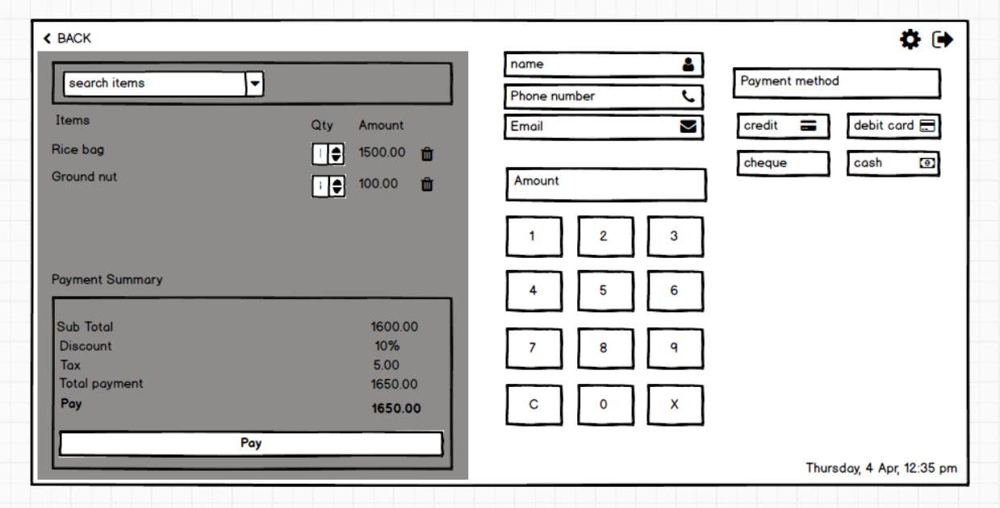

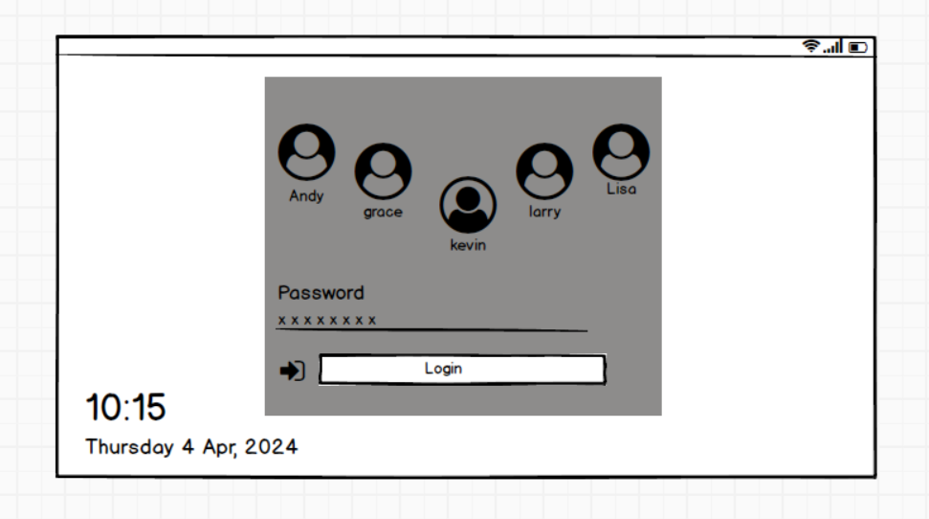

**Document 8- Tools-Visio and Axure**

In my experience, utilizing Visio and Axure for project development has been pivotal, offering distinct advantages in various stages of the project lifecycle:

Visio: Visio has been an invaluable tool for creating comprehensive diagrams and visual representations. Its extensive library of shapes and templates allowed for the rapid development of diagrams, flowcharts, and process maps. These visuals served as powerful communication tools, aiding in conveying complex ideas, system architectures, and workflows to stakeholders and team members. Visio's user-friendly interface facilitated easy customization and arrangement of elements, ensuring clarity and coherence in the presentation of project concepts. Additionally, its integration with other Microsoft Office applications facilitated seamless collaboration and document sharing within the project team.

Axure: Axure emerged as a critical tool for interactive prototyping and wireframing, enabling the development of dynamic, high-fidelity prototypes. Axure's advanced features allowed for the creation of interactive elements, such as clickable buttons, dropdown menus, and form fields, replicating the functionality and user experience of the final product. This capability proved invaluable in eliciting feedback from stakeholders and users during the design phase, as it enabled them to interact with the prototype and provide actionable insights for refinement. Axure's robust simulation capabilities facilitated the identification of usability issues and design flaws early in the development process, mitigating risks and ensuring a more user-centric approach to design.

The combination of Visio and Axure has been instrumental in streamlining project development, from conceptualization to implementation. Visio's ability to create clear and concise visual representations aided in conveying project concepts effectively, while Axure's interactive prototyping capabilities facilitated iterative design improvements based on stakeholder and user feedback. Together, these tools have enhanced collaboration, communication, and the overall success of the project.

**Document 9- BA experience**

**My experience as BA in following phases:**

**1. Requirement gathering:**

* I proactively engaged with stakeholders representing various business units and user groups to understand their needs, preferences, and pain points. Through a combination of interviews, workshops, surveys, and observation sessions.
* I employed a range of elicitation techniques such as brainstorming, document analysis, focus groups, and prototyping to extract requirements effectively. These techniques helped in uncovering both explicit and implicit requirements, ensuring a thorough understanding of the project scope.
* Working closely with stakeholders, I prioritized requirements using techniques like MOSCOW to focus on critical features and functionalities.
* I validated requirements using tools like FURPS to ensure they aligned with business objectives and quality standards.
* Throughout the requirement gathering phase, I remained adaptable and flexible to accommodate evolving business needs and changing project requirements.
* Regular communication and feedback loops with stakeholders helped in addressing emerging requirements and adjusting project plans accordingly.

**2. Requirement Analysis:**

* I ensured a thorough understanding of the business context and objectives underlying the requirements. This involved analyzing industry trends, organizational goals, regulatory requirements, and market dynamics to contextualize the requirements within the broader business landscape.
* I conducted a gap analysis to assess the misalignment between current state and desired future state. This involved comparing existing processes, systems, and capabilities against the desired outcomes specified in the requirements.
* I conducted risk analysis to identify potential threats and uncertainties that could impact the successful delivery of the project.
* Throughout the requirement analysis phase, I collaborated closely with stakeholders to validate and verify the analyzed requirements. This involved conducting reviews, walkthroughs, and validation sessions to gather feedback, clarify ambiguities, and ensure alignment with stakeholder expectations.

**3. Design:**

* I designed the database schema and data model to support the storage and retrieval of information required by the system. This involved identifying entities, attributes, and relationships.
* I created wireframes, mockups, and prototypes to design the user interface (UI) of the system. This involved collaborating with stakeholders to understand their preferences and usability requirements, and iteratively refining the UI design based on feedback and usability testing.
* Update RTM. This is just as we need to make sure that all the requirements

are met.

**4. Development:**

* I organized Joint Application Development (JAD) sessions to gather requirements, clarify doubts, and align stakeholders' expectations.
* I actively engaged with the technical team during the coding phase to address any queries or concerns they had regarding the requirements or design specifications. By providing timely clarification and guidance, I ensured that the development process remained on track and aligned with the project objectives.
* I conducted one-on-one discussions with them to understand their perspectives, address their concerns, and emphasize the importance of their contributions to the project's success. By fostering open communication and collaboration, I was able to mitigate conflicts and establish a healthy team environment conducive to productivity and innovation.
* I utilized diagrams and visual representations created during the requirement analysis and design phases as references for coding. These diagrams provided clarity on system architecture, data flow, and component interactions, helping developers to translate design specifications into functional code efficiently and accurately.
* I ensured regular communication and collaboration by scheduling regular meetings and maintaining clear communication channels.
* Overall, my approach to the development phase focused on fostering collaboration, addressing conflicts, providing support to the technical team, and maintaining effective communication with all stakeholders. By leveraging JAD sessions, visual references, and regular meetings, I facilitated a cohesive and productive development process that resulted in the successful implementation of the project.

**5. Testing:**

* I translated the functional requirements documented in use cases into detailed test cases. These test cases were designed to validate the functionality of the system and ensure that it met the specified requirements.
* I collaborated with the QA team to review and refine the test cases as needed.
* I conducted high-level testing to verify the overall functionality and usability of the software solution. This involved performing initial smoke tests or sanity checks to ensure that the basic functionality of the system was working as expected before proceeding with more detailed testing.
* As the BA, I liaised with the client to gather test data required for testing various scenarios. This involved understanding the data requirements for different test cases, coordinating with the client to obtain relevant data sets, and ensuring that the test environment was properly configured with the necessary data.
* I maintained and updated the Requirements Traceability Matrix (RTM) to track the coverage of requirements through various testing phases. This involved mapping test cases to specific requirements and updating the RTM with the status of each requirement based on the results of testing.
* Once testing was completed and the software solution met the acceptance criteria, I facilitated the process of obtaining signoff from the client. This involved presenting the test results, demonstrating the functionality of the system, and addressing any outstanding issues or concerns raised by the client.
* I prepared the client for User Acceptance Testing (UAT) by providing guidance on the testing process, explaining the objectives and scope of UAT, and assisting in the preparation of test scenarios and test data. I ensured that the client had a clear understanding of their role and responsibilities during UAT and provided support as needed throughout the testing process.
* Overall, my involvement in the testing phase focused on ensuring thorough testing, effective test data management, maintaining traceability, obtaining client signoff, and preparing the client for UAT. By collaborating closely with the QA team and the client, I contributed to the successful validation of the software solution and its readiness for deployment.

**6. Deployment:**

* I forwarded the Requirements Traceability Matrix (RTM) to the client as part of the project closure documentation. The RTM served as a comprehensive record of the requirements and their validation status throughout the project lifecycle, providing transparency and accountability.
* I collaborated with technical writers or documentation specialists to complete and share end user manuals. These manuals provided essential guidance and instructions for end users on how to use the software solution effectively, troubleshoot common issues, and leverage its features to achieve their objectives.
* I planned and organized training sessions to ensure that end users were adequately trained on how to use the software solution. This involved identifying training needs, scheduling training sessions, preparing training materials, and coordinating logistics such as venue, equipment, and trainers.
* I made sure that all relevant stakeholders, including end users and project team members, attended the training sessions and deployment meetings. This involved sending out invitations, reminders, and follow-ups to ensure that everyone was aware of the schedule and importance of their participation.
* Overall, my involvement in the deployment phase focused on facilitating knowledge transfer, enabling end users to effectively use the software solution, and ensuring a smooth transition to production. By coordinating documentation, training, and communication efforts, I contributed to the successful adoption and implementation of the software solution within the organization.